SREE NARAYANA COLLEGE, SIVAGIRI, VARKALA,
THE DEPARTMENT OF HISTORY

BROCHURE

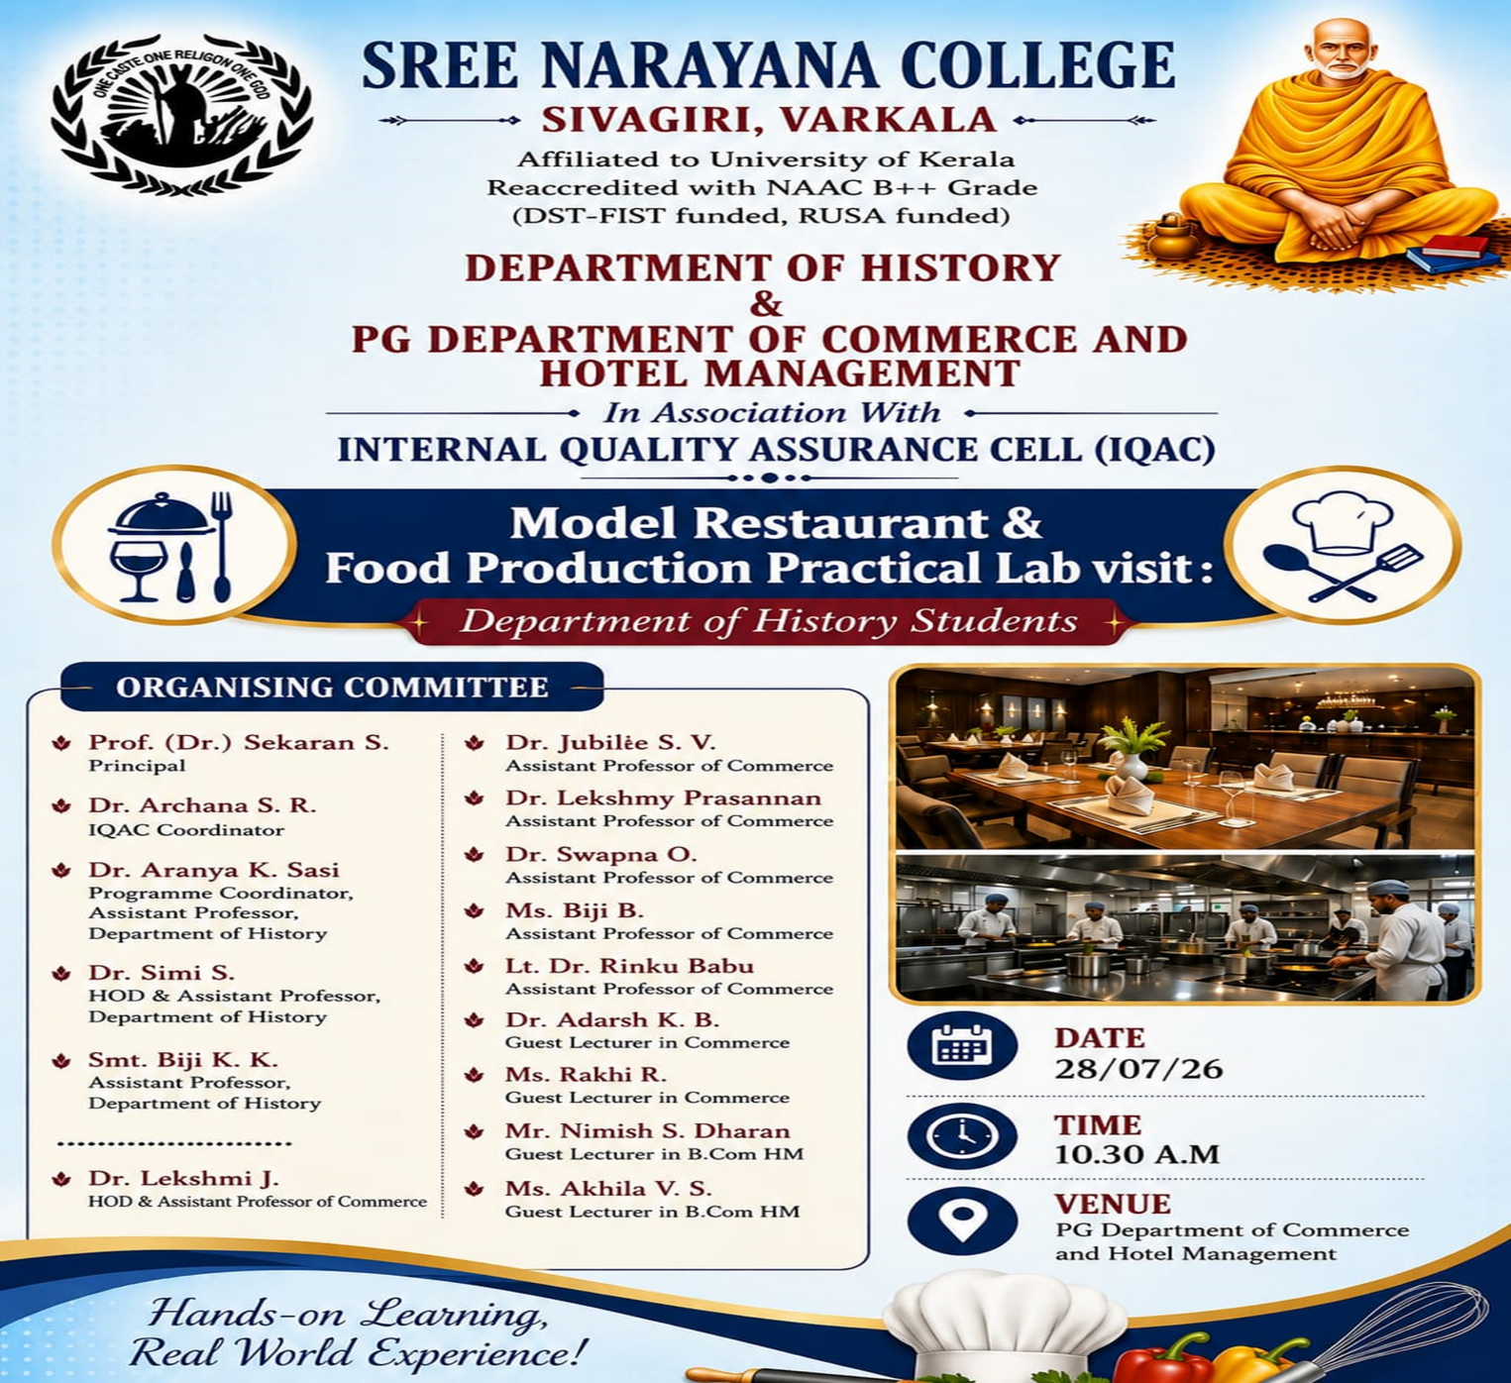

PHOTOS
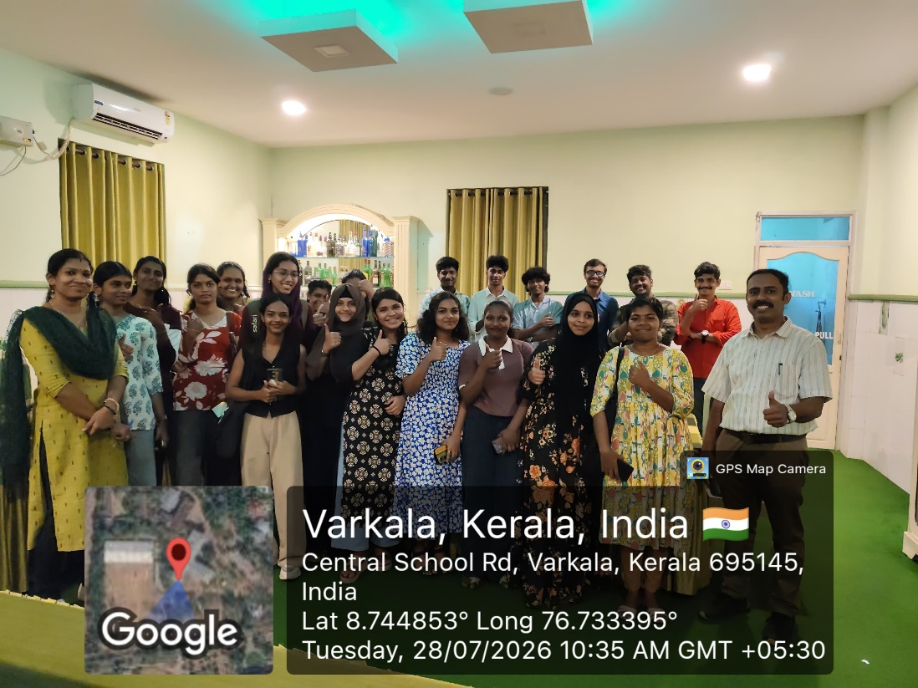

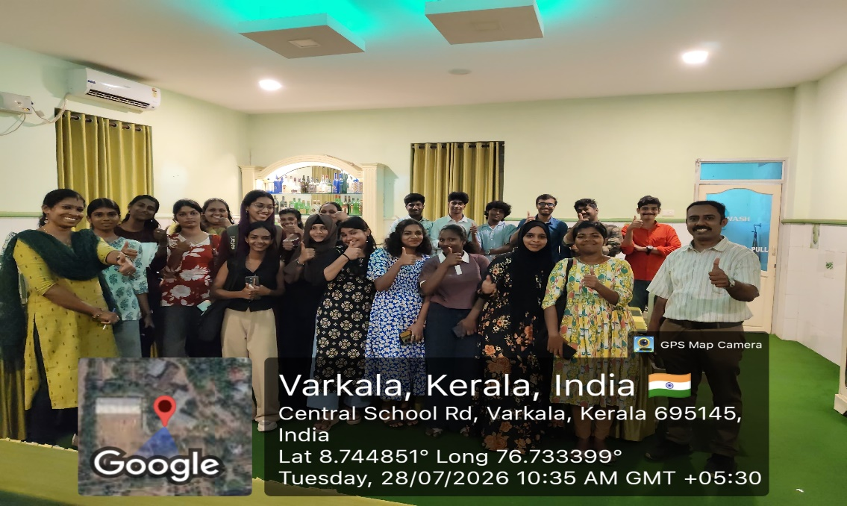
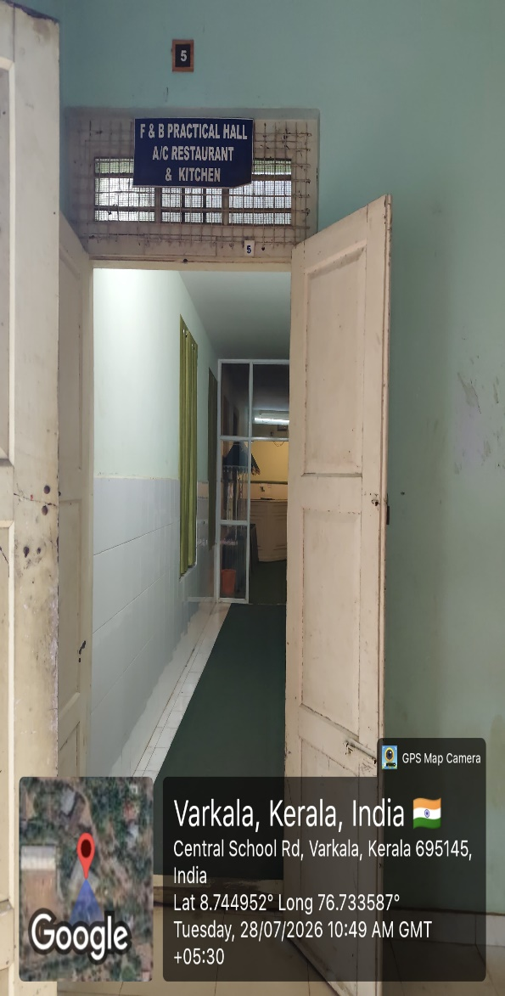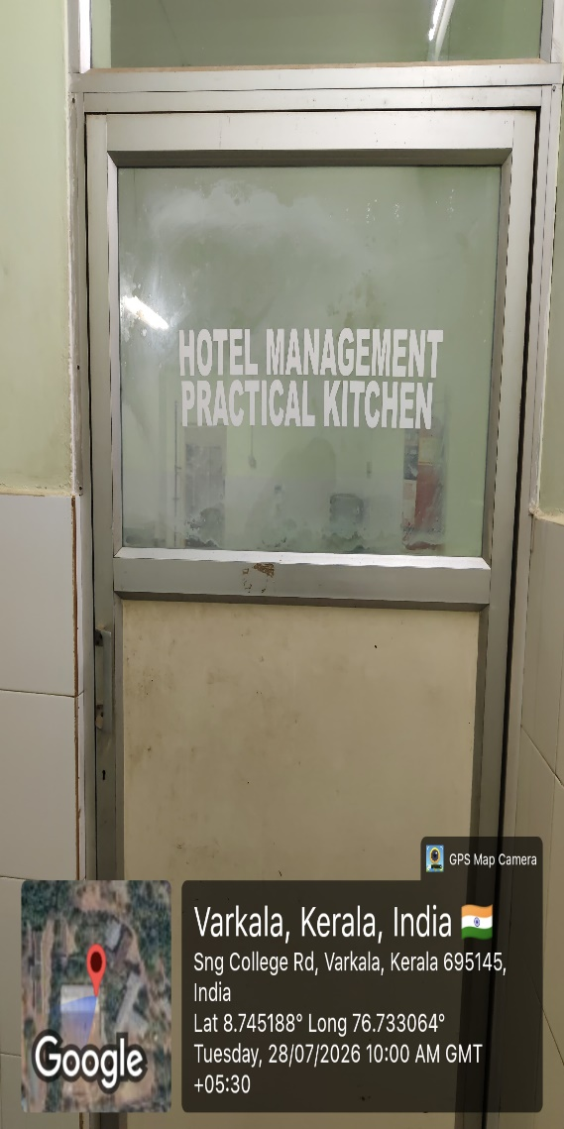
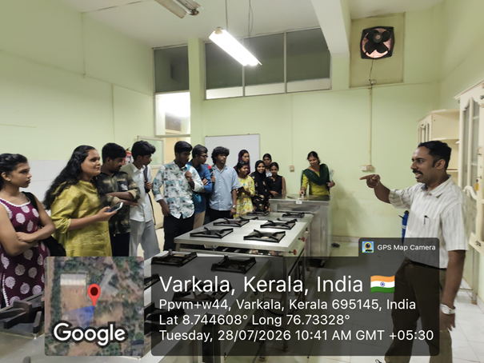

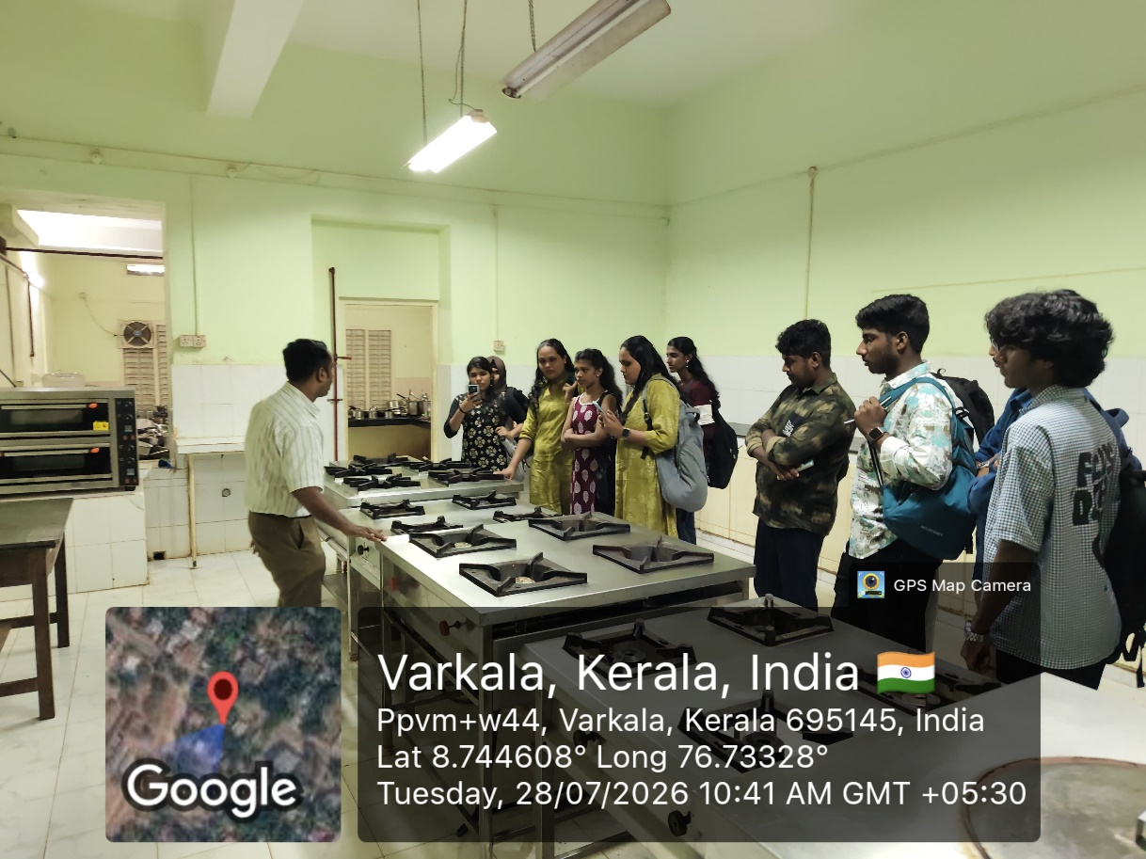
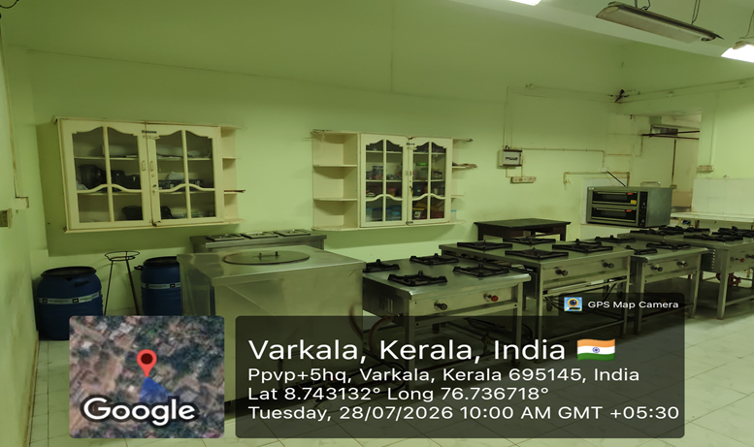
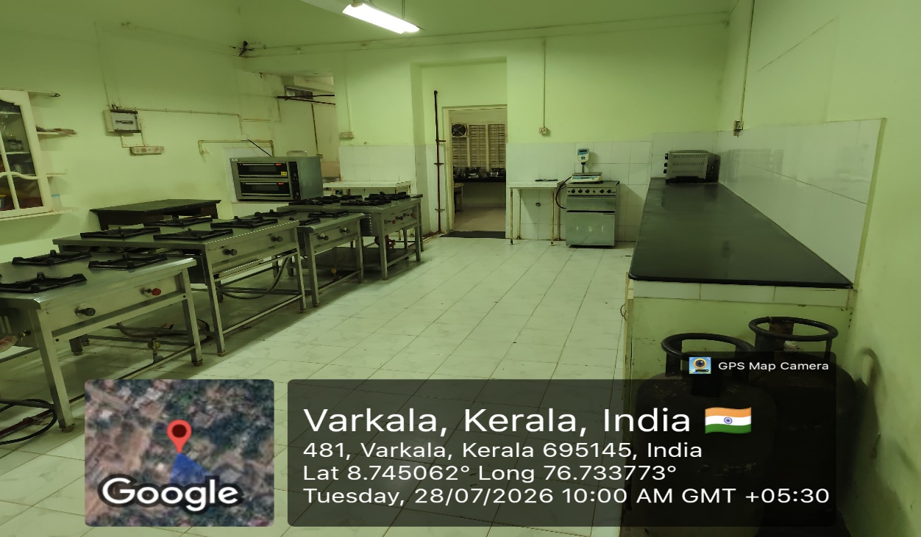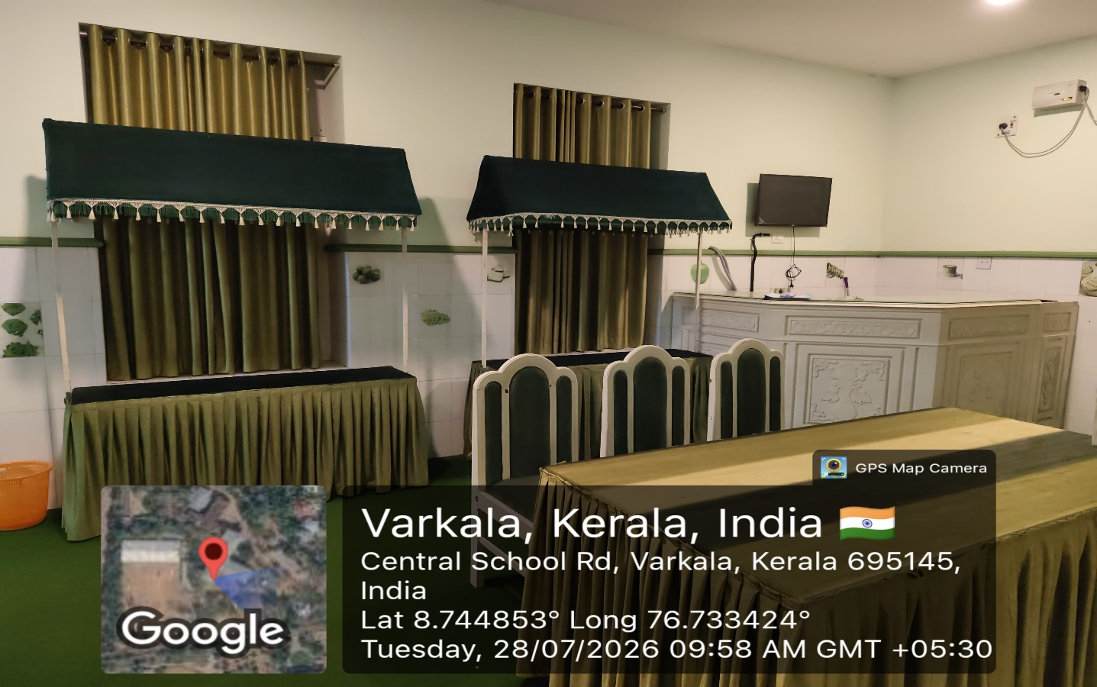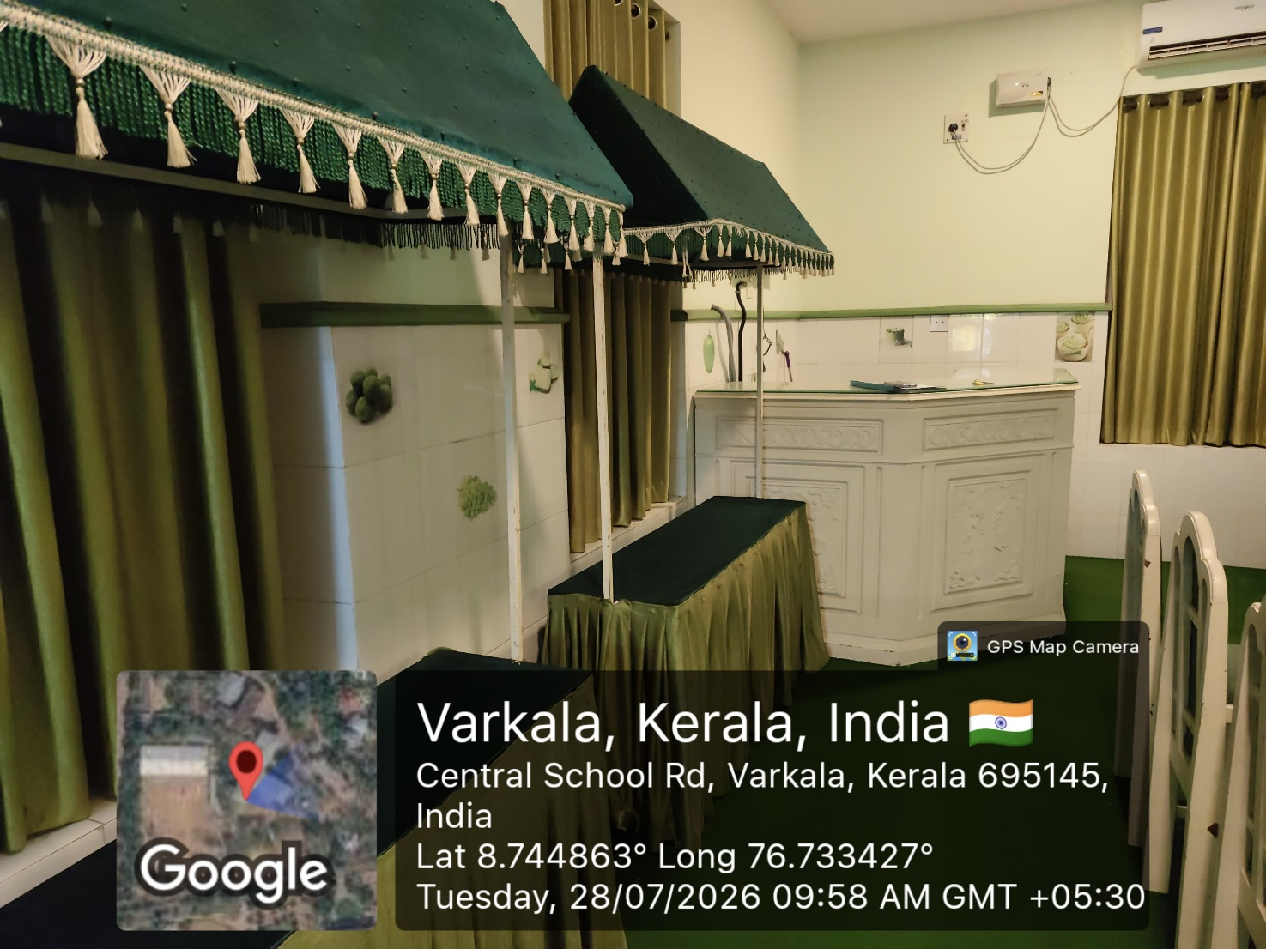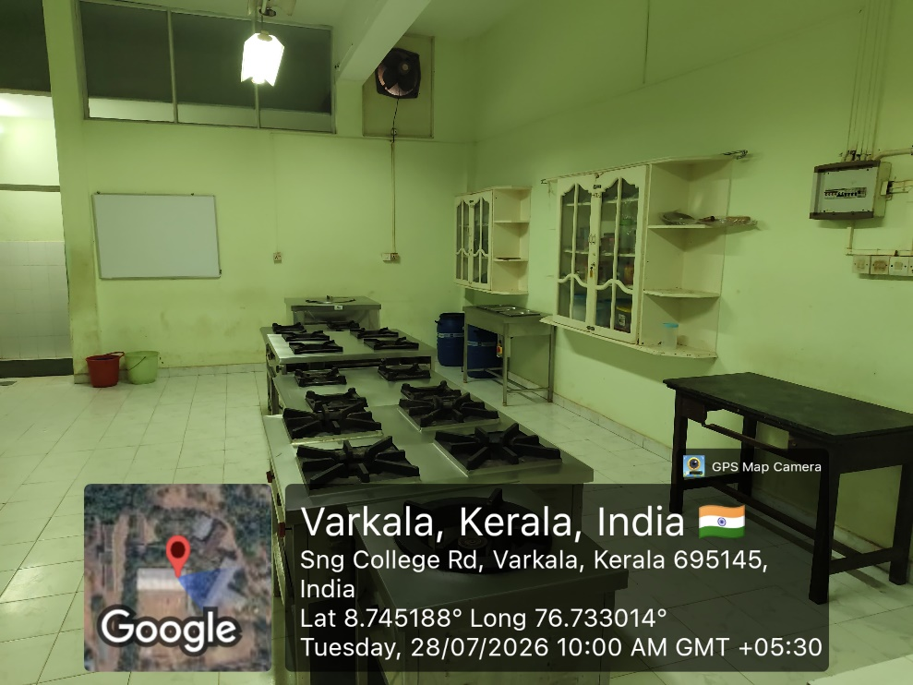
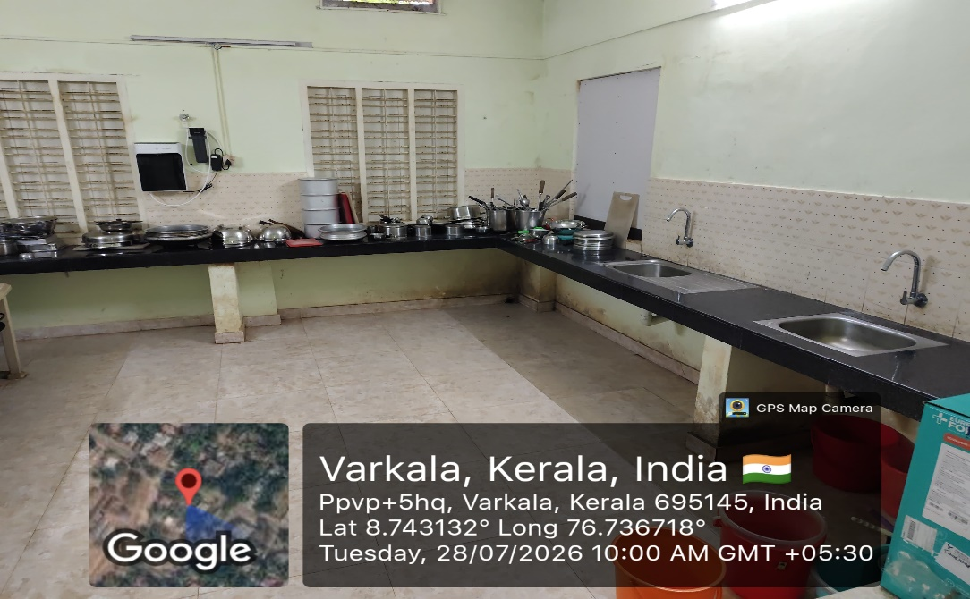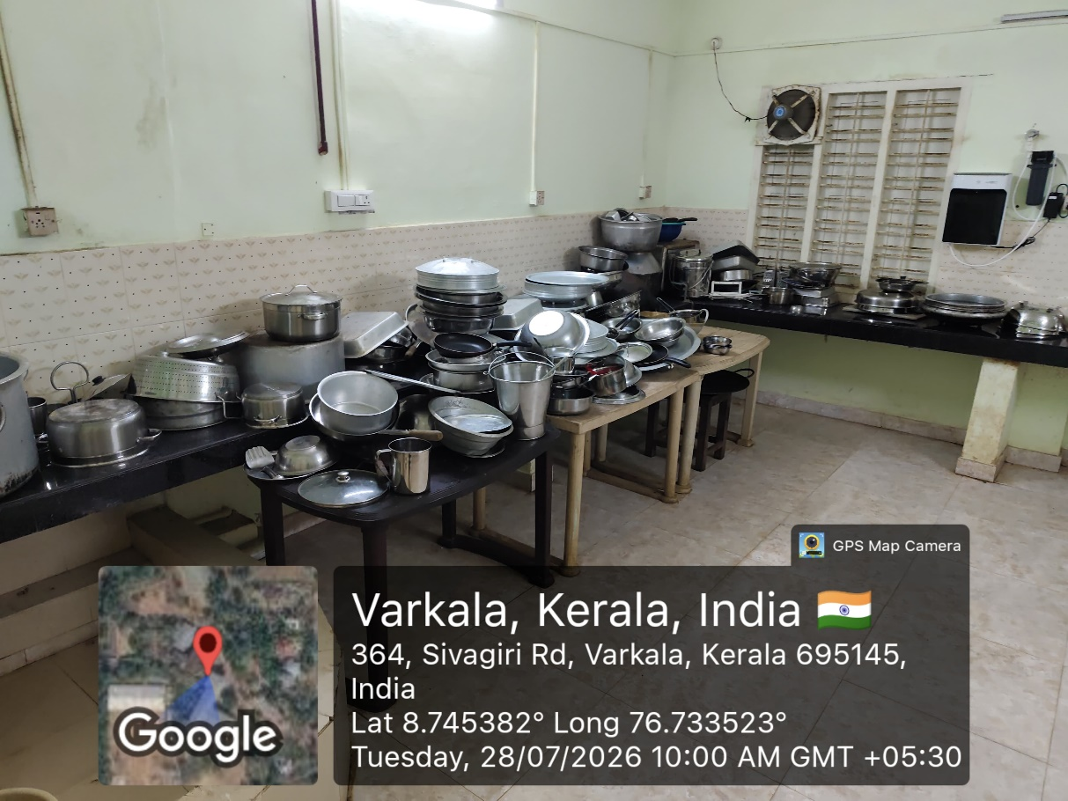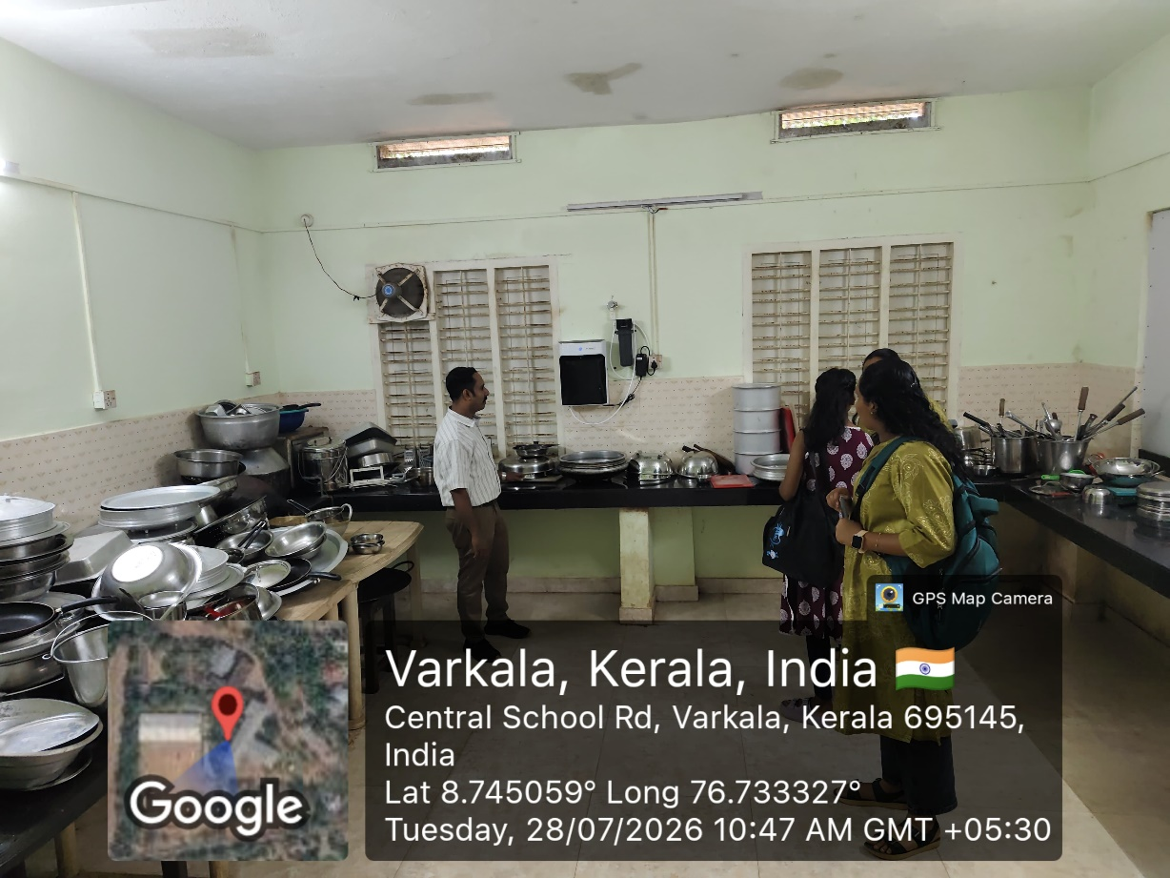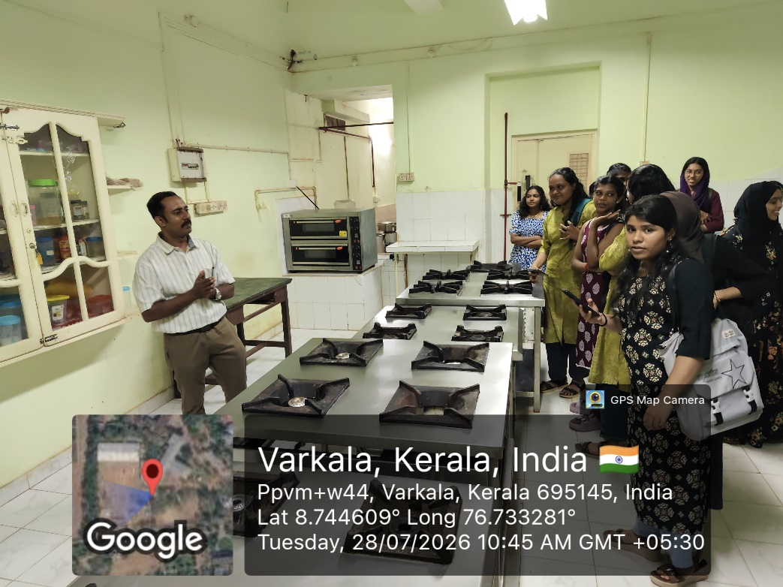

REPORT

History in the Hospitality Industry: Learning from the Past
The Department of History, in association with the Internal Quality Assurance Cell (IQAC), Sree Narayana College, Sivagiri, Varkala, conducted a Bridge Course session titled "History in the Hospitality Industry: Learning from the Past" on 28 July 2026 at the P.G. Department of Commerce & Hotel Management.
The session was handled by Mr. Nimish S. Dharan, Assistant Professor (on Contract), P.G. Department of Commerce and Hotel Management. He provided students with an insightful overview of the historical evolution of the hospitality industry, highlighting how cultural heritage, traditional hospitality practices, and historical developments have shaped the modern tourism and hotel sectors.
The interactive programme enabled FYUGP History students to appreciate the interdisciplinary relevance of history in contemporary professional fields. The session concluded with an engaging discussion, inspiring students to explore the connections between historical knowledge and career opportunities in the hospitality industry.

