SREE NARAYANA COLLEGE, SIVAGIRI, VARKALA,
THE DEPARTMENT OF HISTORY

Bridge Course Session on Hotel Management
BROCHURE
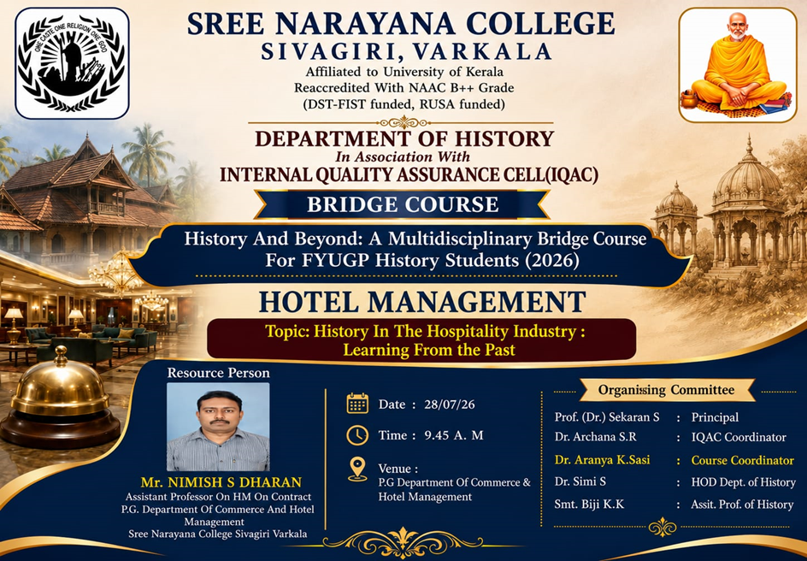

PHOTOS
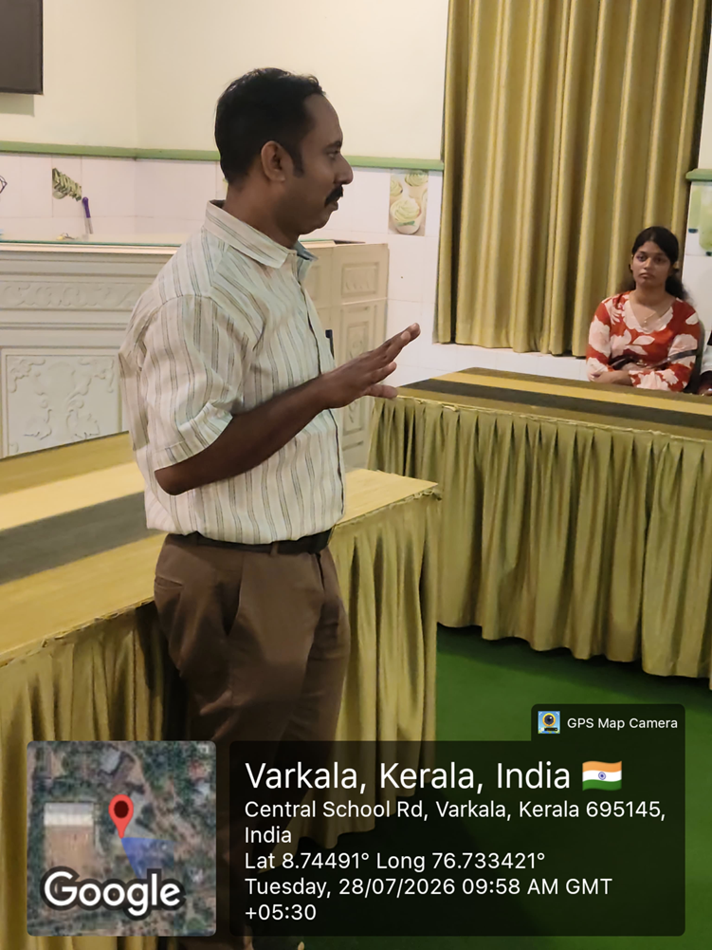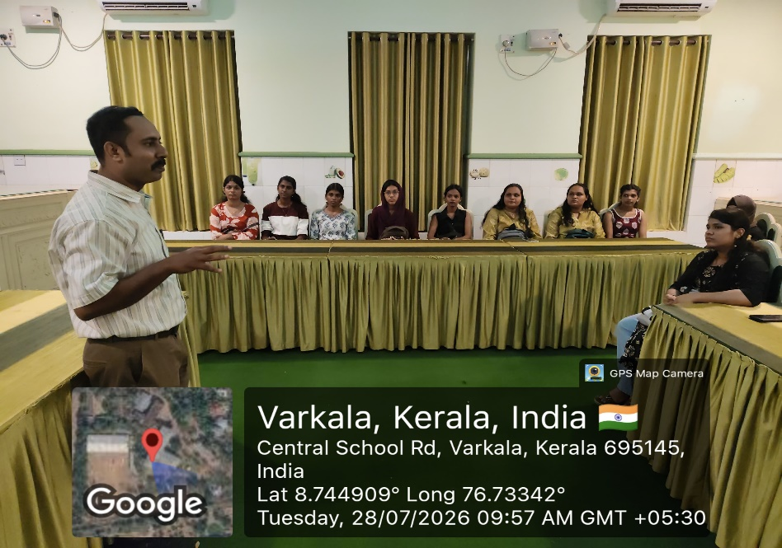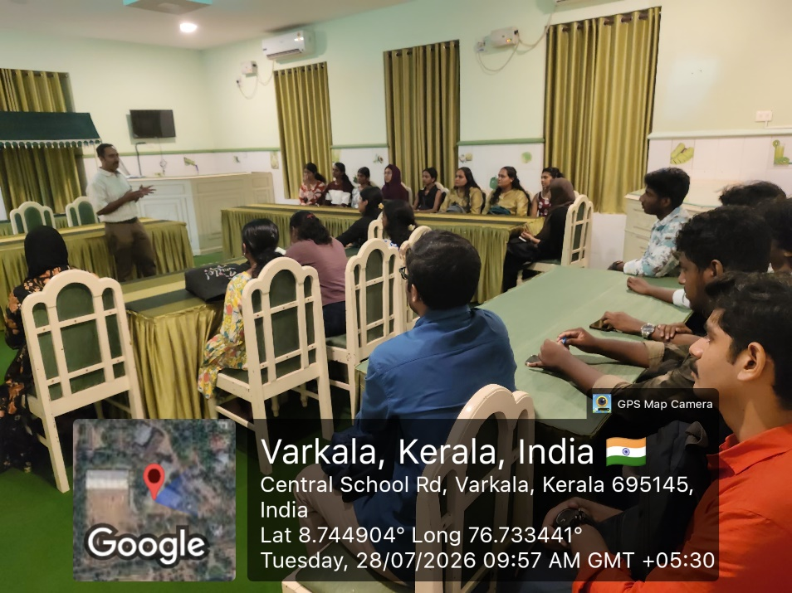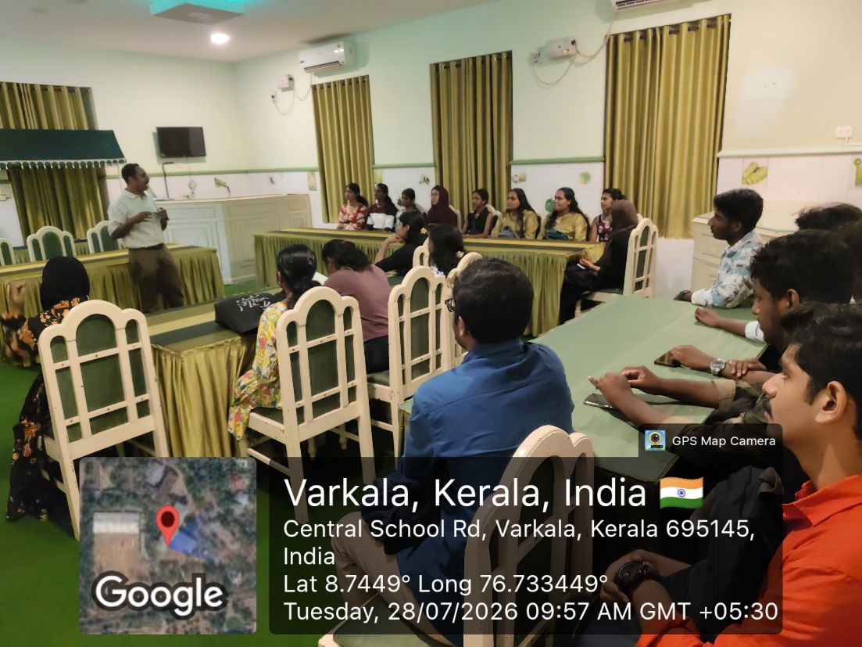

REPORT
The Department of History, in association with the Internal Quality Assurance Cell (IQAC), Sree Narayana College, Sivagiri, Varkala, successfully organized a Bridge Course session titled "History and Beyond: A Multidisciplinary Bridge Course for FYUGP History Students (2026)" on 28 July 2026 at 9.45 A.M. in the P.G. Department of Commerce & Hotel Management.
The session, on the topic "History in the Hospitality Industry: Learning from the Past," was led by Mr. Nimish S. Dharan, Assistant Professor (on Contract), P.G. Department of Commerce and Hotel Management, Sree Narayana College, Sivagiri, Varkala.
The resource person explained the historical evolution of the hospitality industry, tracing its development from ancient inns, rest houses, and caravanserais to modern hotels and tourism establishments. The session highlighted how history, culture, architecture, and traditional hospitality practices have shaped the contemporary hospitality sector. Students were introduced to the significance of preserving heritage while meeting the changing demands of global tourism and customer service.
The programme was organized under the guidance of Prof. (Dr.) Sekaran S., Principal, with the support of Dr. Archana S.R., IQAC Coordinator, Dr. Aranya K. Sasi, Course Coordinator, Dr. Simi S., Head of the Department of History, and Smt. Biji K.K., Assistant Professor, Department of History.
The interactive session encouraged students to appreciate the interdisciplinary connection between History and Hotel Management. The programme concluded with an engaging discussion and active participation from the students, making the session informative and enriching.

