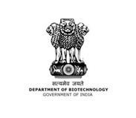
SREE NARAYANA COLLEGE SIVAGIRI, VARKALA
DEPARTMENT OF CHEMISTRY
REPORT ON THE HANDS-ON TRAINING ON ‘SOAP MAKING’
Conducted on 14th July 2022 in Association with DBT STAR
Venue- Seminar Hall
On 14th July 2022, Department of Chemistry of S.N College Varkala organized a hands-on training on ‘SOAP MAKING’ by Smt.Uma Sunil Babu, Entrepreneur, ‘Freezia’ Hand Crafted Soaps and Skin Care Products, Varkala as part of DBT Star Scheme. The programme commenced at 1.30pm with prayer. The event was inaugurated by the resource person with the lighting of the ceremonial lamp. This was followed by welcome address delivered by Smt.Lekshmi S Dharan, Assistant Professor in Chemistry. Dr. K.C.Preetha, Principal, Sree Narayana College, Sivagiri, Varkala presided over the session. S.N.Trust Executive Member Sri.Aji.S.R.M and Head of the department Dr.Archana.S.R felicitated the function. Then Smt.Uma Sunil Babu delivered a motivational speech to our students. The I M.Sc Chemistry student Athira.S gave an introduction about the resource person. The presenter who herself is a source of motivation to students gave encouraging examples from her own life and inspired students to be a self-motivator. She discussed the importance of confidence and attitude which brings optimism into life and such constructive changes can make one brighter and more successful.
Soap is a salt of a fatty acid used in a variety of cleansing and lubricating products. In a domestic setting, soaps are surfactants usually used for washing, bathing, and other types of housekeeping. In industrial settings, soaps are used as thickeners, components of some lubricants, and precursors to catalysts. Handcrafted soap is made with natural, wholesome ingredients that cleanse without stripping skin of its natural oils. In contrast, commercially-made bars are made with chemical additives, or synthetic detergents.
Smt. Uma Sunil Babu gave a hands-on training on soap making with natural ingredients such as turmeric, neem, carrot, beet root and Aloe vera. In the training session around thirty soaps were prepared. She also gave a lecture on the history of soap, different types of soaps and advantages of handcrafted soaps.
The training session encouraged many of the students. An interaction session was held with the students to get their doubts clarified. The programme was very fruitful to all participants in the programme. Students and faculty members of our college were actively participated in the session. The class helped the students to understand the benefits of handmade soaps for healthy life style. The training was very fruitful to all participants. Ms.Pallavi Mohan, I M.Sc Chemistry student delivered the vote of thanks and the session ended at 3.30 pm.
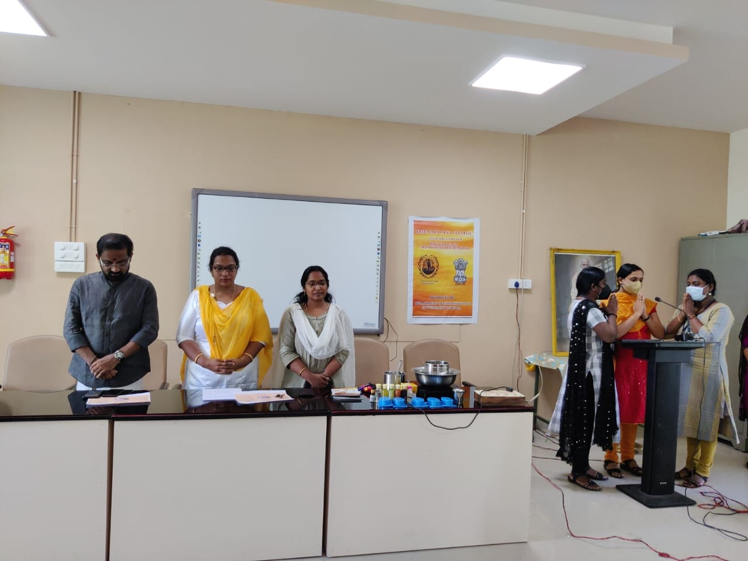
Prayer
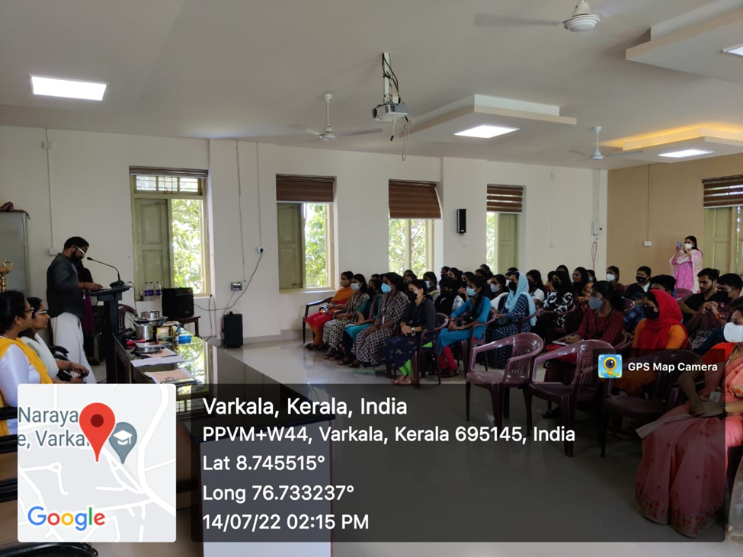
Felicitation
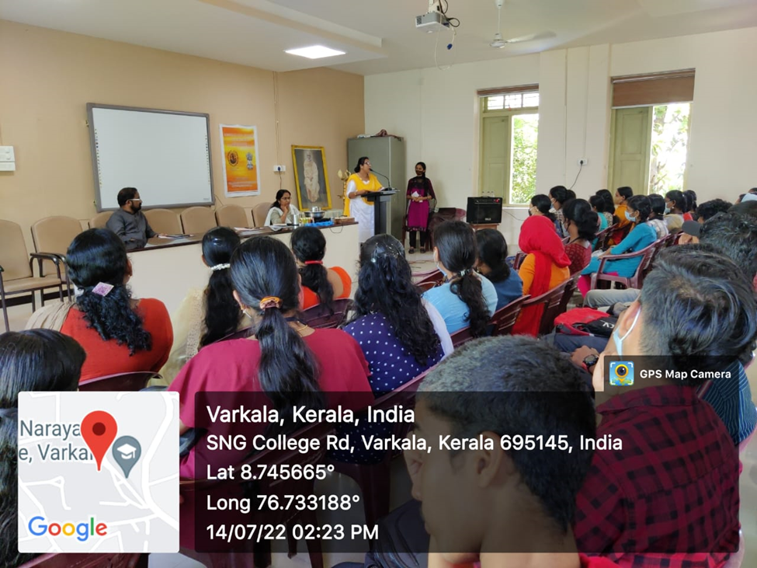
Inaugural Address
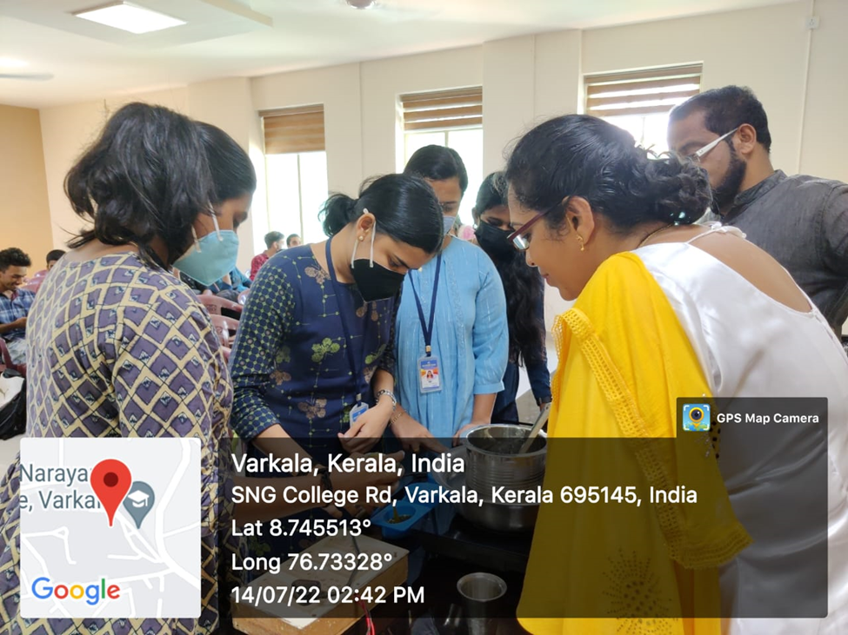
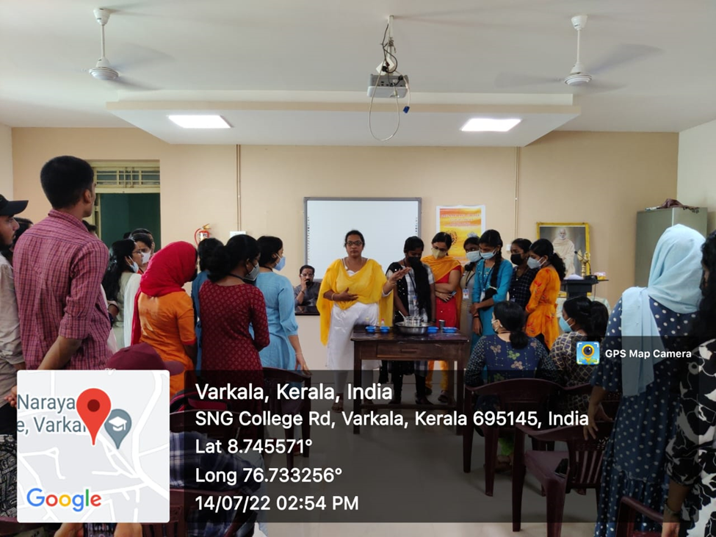
Participation of students in Hands-on training
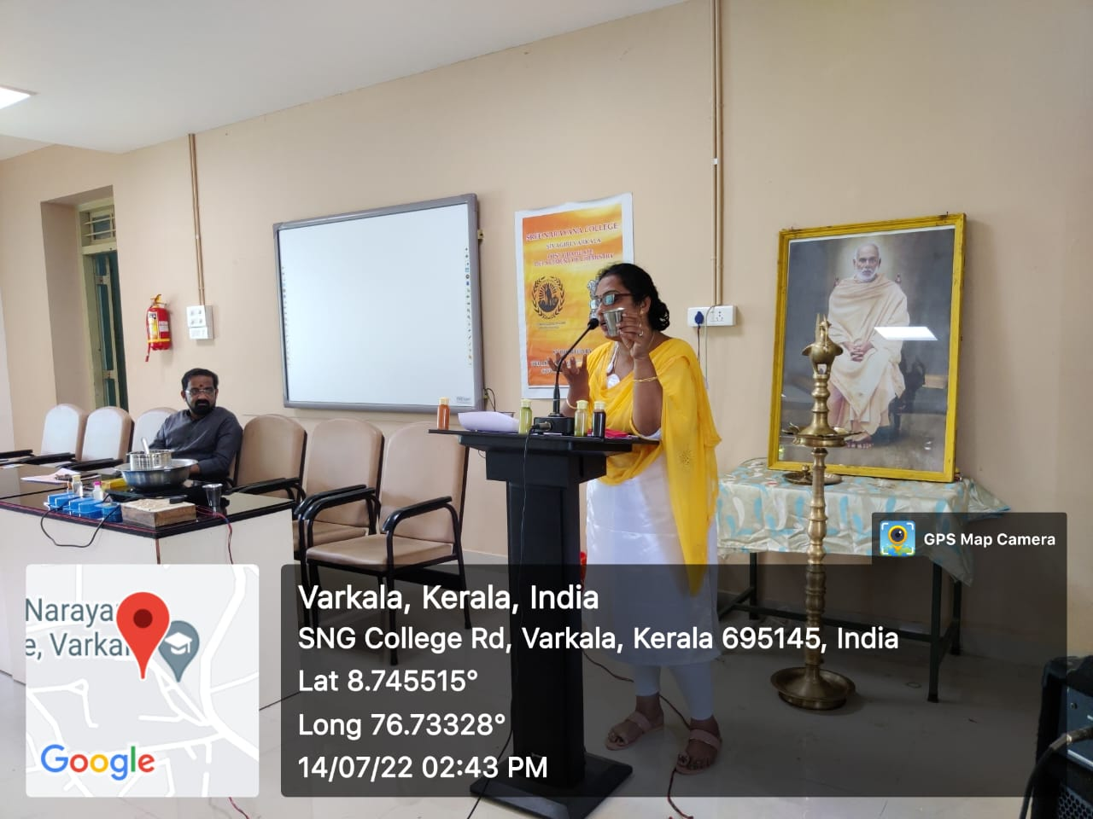Demonstration
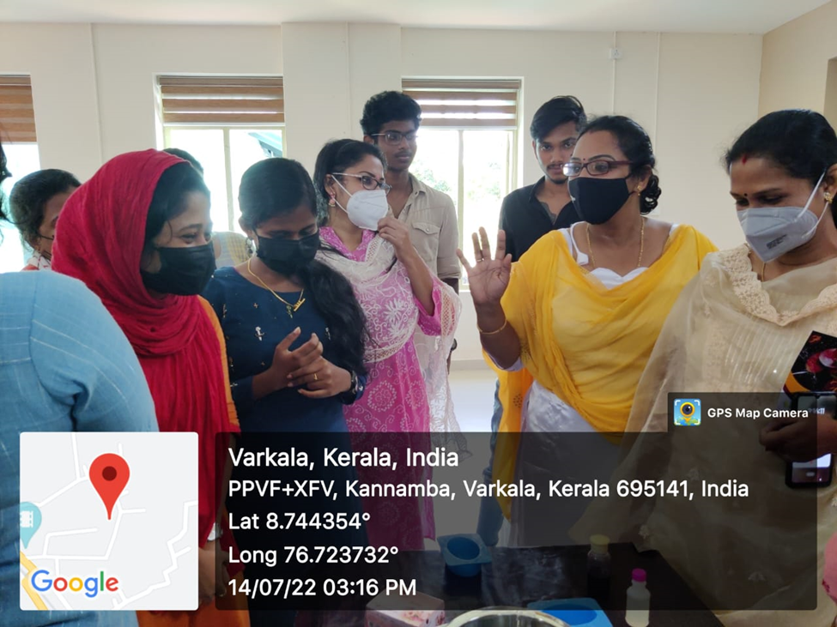
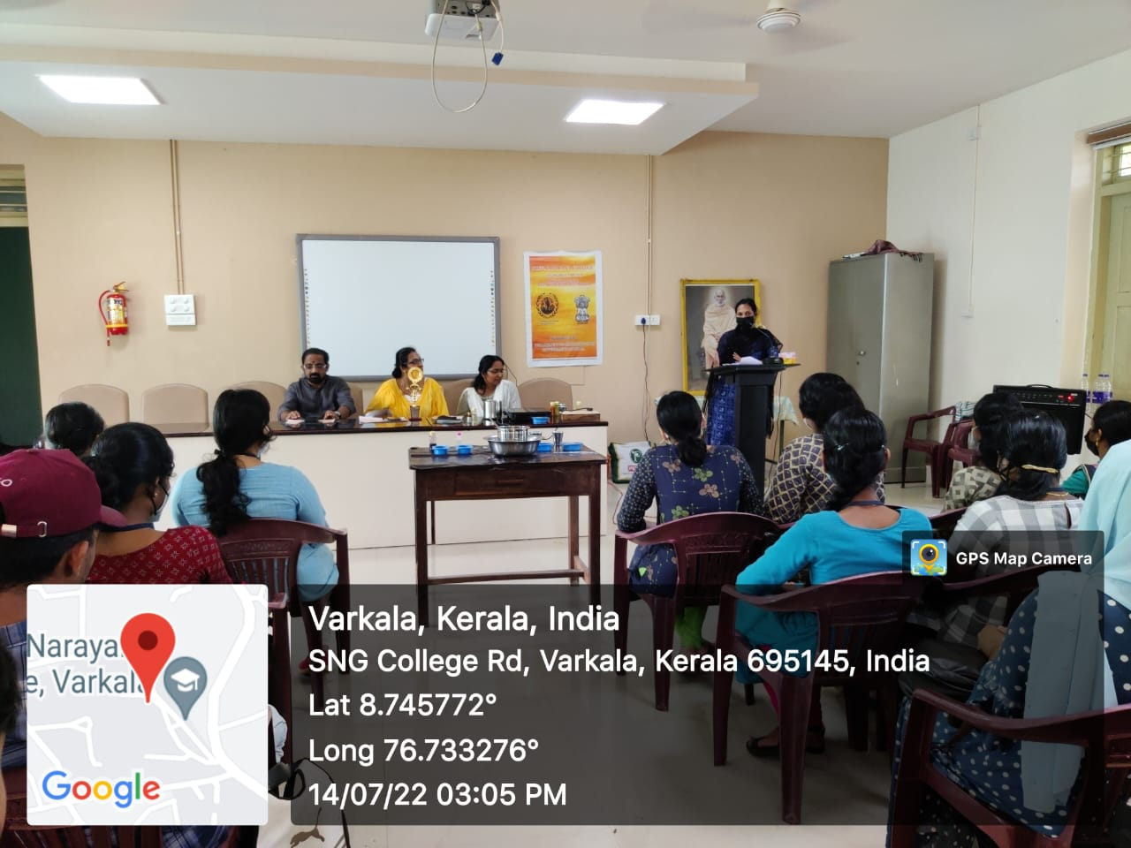
Delivering Vote of thanks

