SREE NARAYANA COLLEGE, SIVAGIRI, VARKALA,
THE DEPARTMENT OF HISTORY

Kargil Vijay Diwas Commemorative Quiz 2026

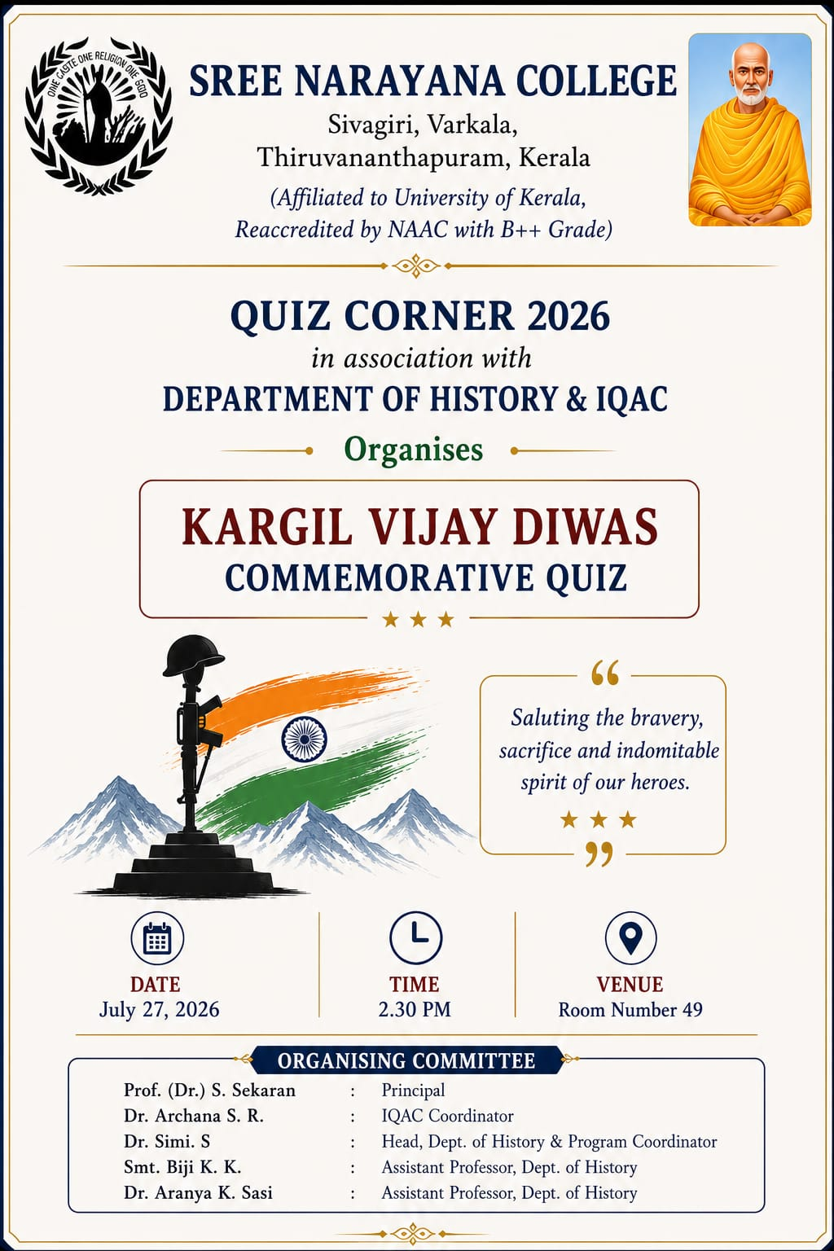

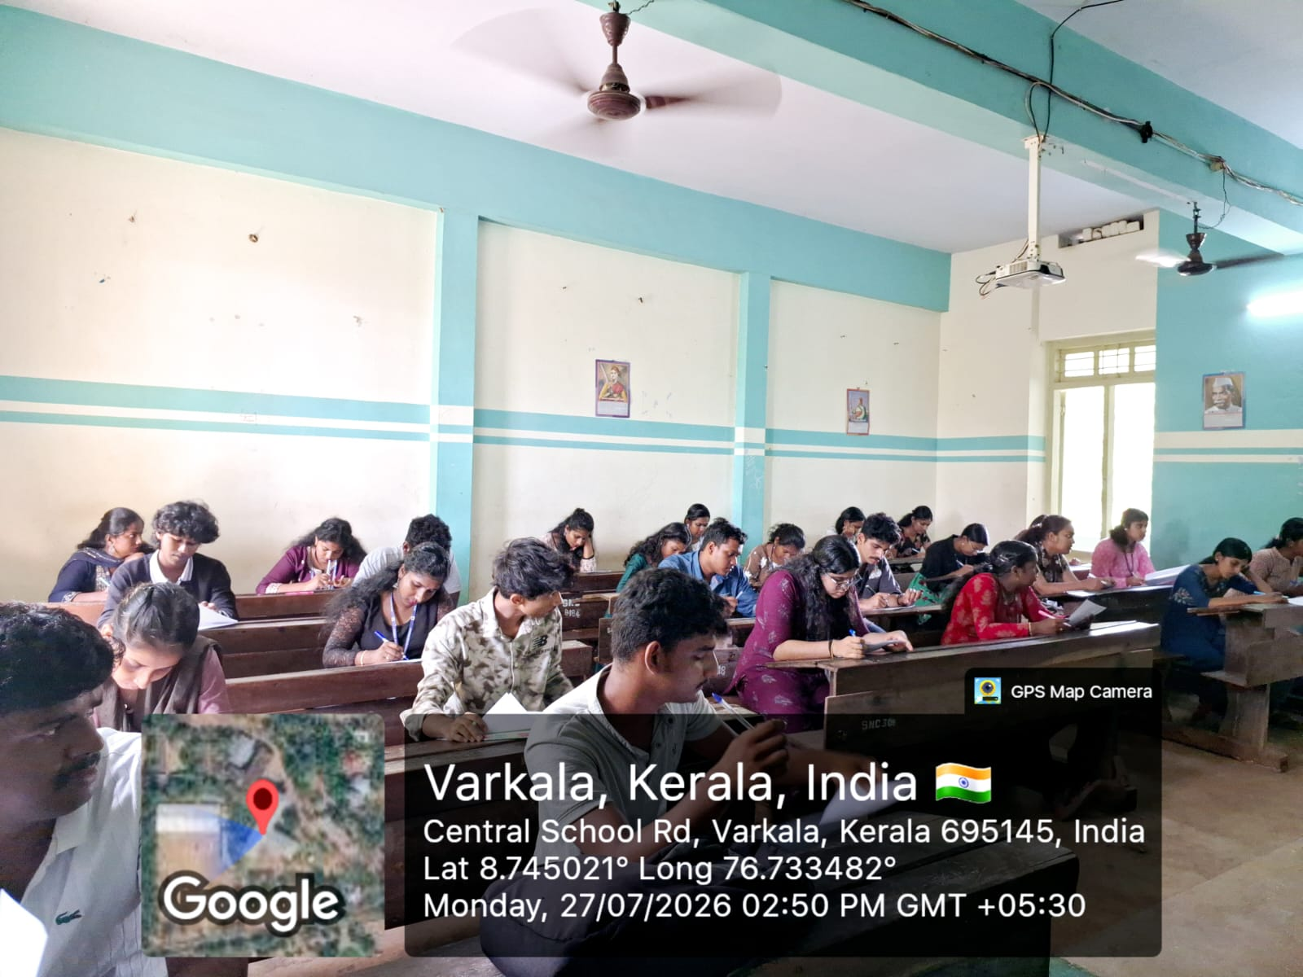

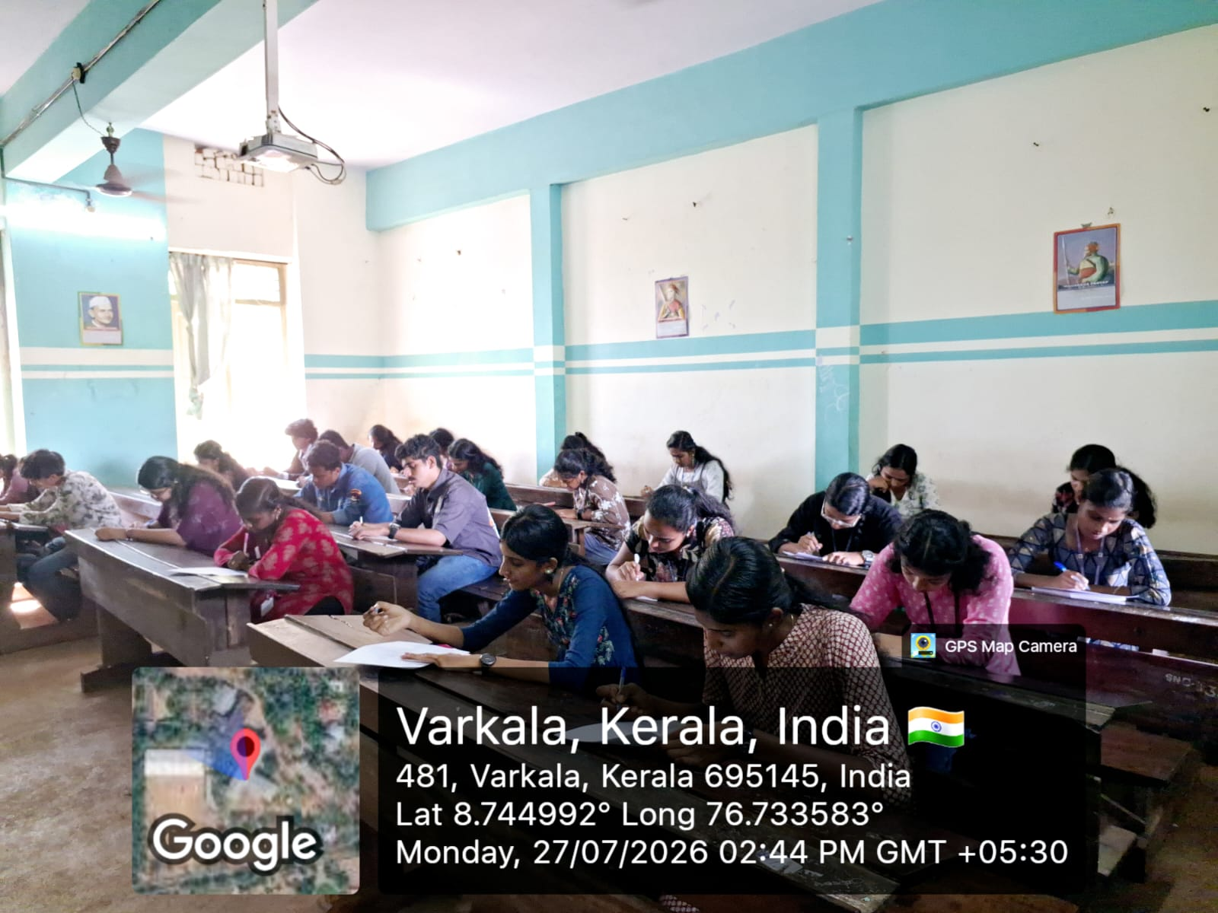

REPORT

Kargil Vijay Diwas Commemorative Quiz 2026
The Kargil Vijay Diwas Commemorative Quiz was successfully organized by the Quiz Corner 2026 in association with the Department of History & IQAC, Sree Narayana College, Sivagiri, Varkala, on 27 July 2026 at 2.30 PM in Room No. 49.
The programme was conducted to commemorate Kargil Vijay Diwas and to instill a sense of patriotism, national pride, and awareness about the courage, sacrifice, and achievements of the Indian Armed Forces among students. The quiz featured questions on the Kargil War, Indian military history, national security, and personalities associated with the conflict.
A total of 31 students from various departments enthusiastically participated in the competition. The event witnessed healthy competition and active involvement from the participants, making it a meaningful tribute to the brave soldiers who laid down their lives for the nation.

Prize Winners

First Prize
- Bheeshma A. J. – II B.Sc. Physics
- Adwaith G. B. – I B.A. History

Second Prize
- Sreevinayak R. S. – III B.Sc. Zoology
- Revathy A. – III B.Sc. Chemistry
- Richu Chandran R. – II B.Sc. Physics

Third Prize
- Aswathy R. S. – III B.Sc. Physics
- Alakananda S. – III B.A. History
The programme concluded with the announcement of the winners and appreciation of all participants for their enthusiastic involvement. The event successfully fulfilled its objective of honouring the spirit of Kargil Vijay Diwas while promoting historical awareness and patriotic values among students.

