SREE NARAYANA COLLEGE, SIVAGIRI, VARKALA,
THE DEPARTMENT OF HISTORY

Bridge Course Session on Mathematics

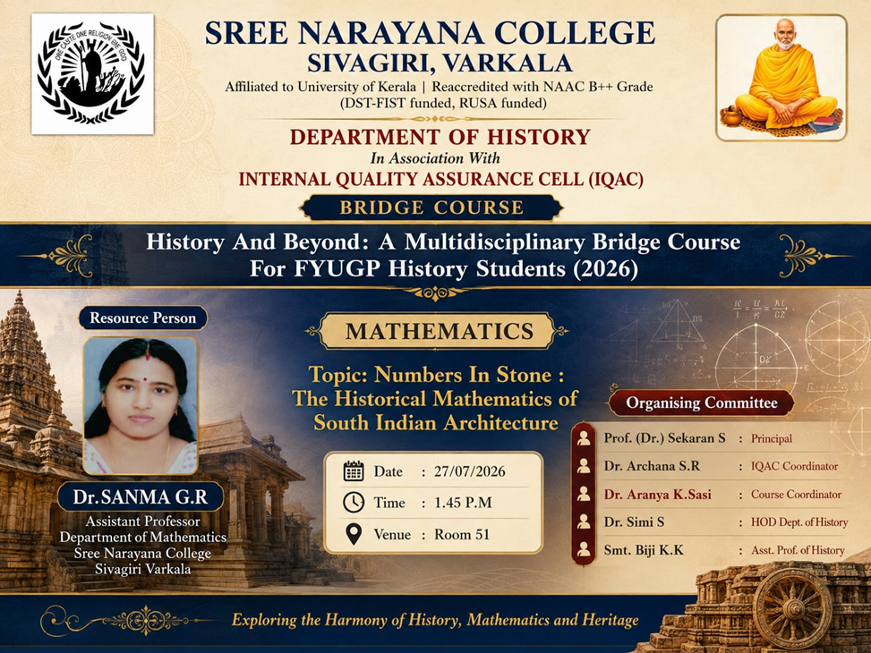

Photos

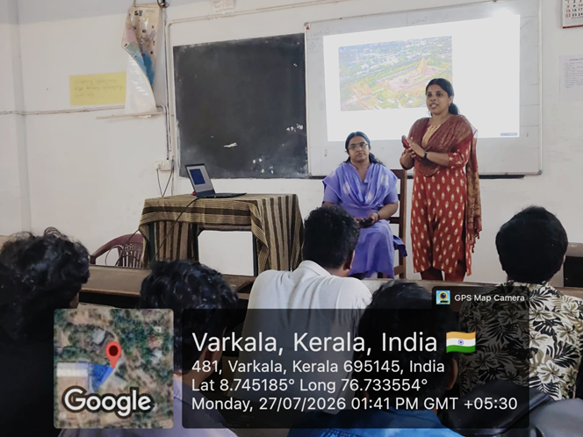

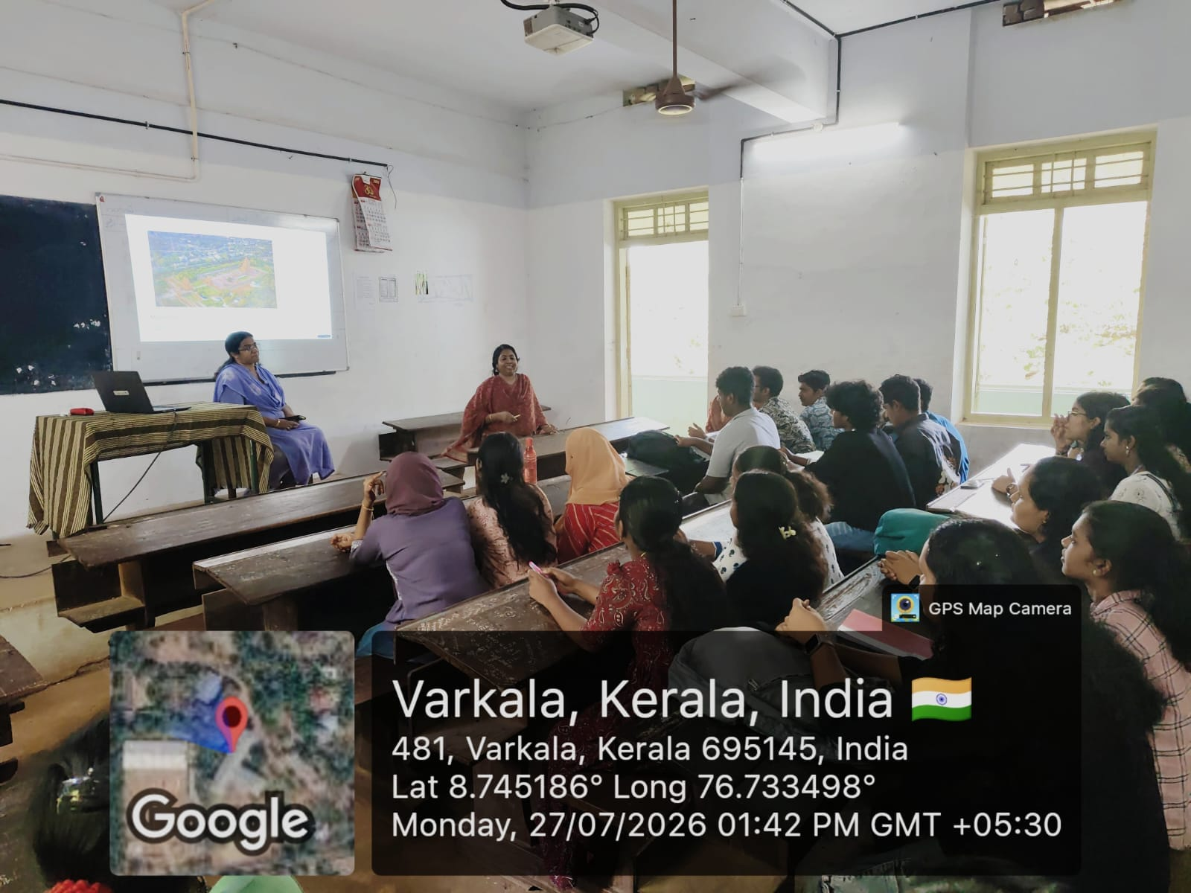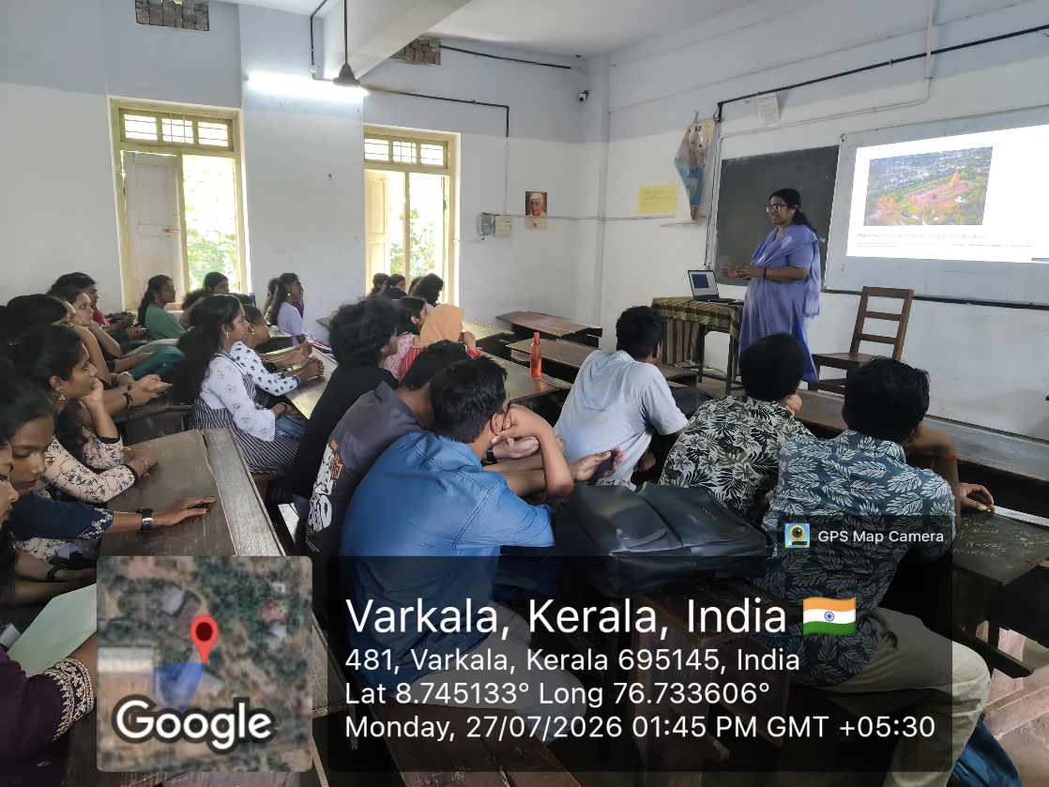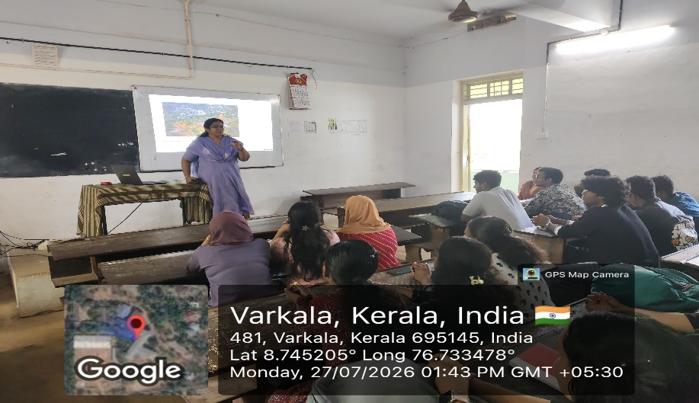

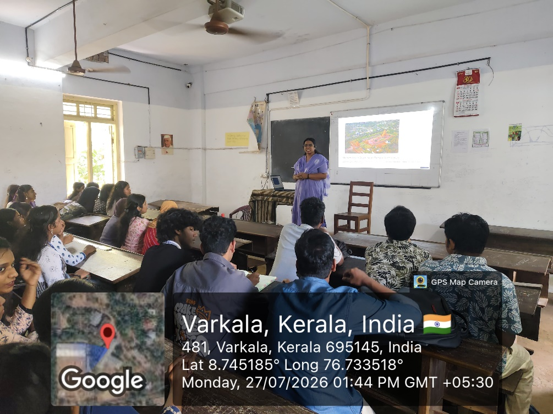

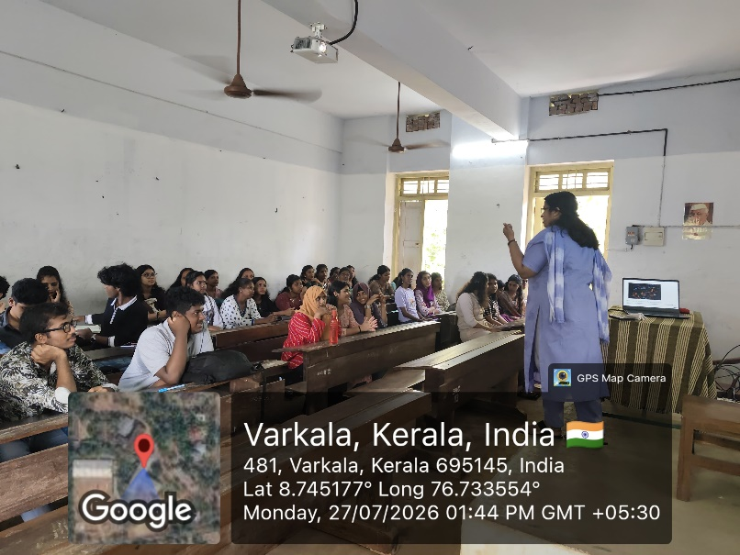

REPORT

Bridge Course Session on Mathematics
As part of the Bridge Course 2026 – History and Beyond: A Multidisciplinary Bridge Course for FYUGP History Students, the Department of History, in association with the Internal Quality Assurance Cell (IQAC), Sree Narayana College, Sivagiri, Varkala, organized an interdisciplinary session on Mathematics on 27 July 2026 at 1.45 PM in Room No. 51.
The session was handled by Dr. Sanma G. R., Assistant Professor, Department of Mathematics, Sree Narayana College, Sivagiri, Varkala, on the topic "Numbers in Stone: The Historical Mathematics of South Indian Architecture."
The resource person introduced students to the fascinating relationship between mathematics, history, and architecture, demonstrating how mathematical concepts were embedded in the planning and construction of South Indian temples and monuments. The session highlighted geometric principles, symmetry, proportions, measurements, and architectural precision employed by ancient builders, enabling students to appreciate the scientific knowledge reflected in historical structures.
Through engaging explanations and illustrations, the session encouraged students to view history from an interdisciplinary perspective and understand the role of mathematics in interpreting architectural heritage. The interactive nature of the programme inspired students to explore the connections between the humanities and sciences, making the learning experience both informative and engaging.
The programme concluded with an interactive discussion, during which students actively participated by asking questions and sharing their observations. The session successfully achieved its objective of broadening students' understanding of the multidisciplinary nature of history and promoting appreciation for India's rich architectural and scientific heritage.

