SREE NARAYANA COLLEGE, SIVAGIRI, VARKALA
WORLD ENVIRONMENT DAY CELEBRATIONS 2022
‘World Environment Day’ is being celebrated on June 5 every year to provide awareness to protect our environment. The theme of ‘World Environment Day 2022’ is ‘Only One Earth’. Sweden is the host of ‘World Environment Day 2022’.
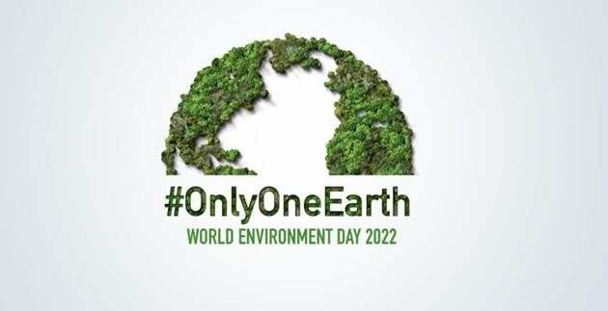

As part of ‘World Environment Day Celebration 2022’, PG Department of Chemistry organized several DBT Star Scheme supported programmes such as Planting Saplings, Poster and Powerpoint presentations on 9th June 2022. The programme started with prayer by the students Sivapriya S and Akhila L S (I B.Sc. Chemistry). The celebration was inaugurated by the HoD of Chemistry, Mrs. Reshmi Jaya Raveendran, by lighting the lamp. Planting saplings were done by HoD of Chemistry, Mrs. Reshmi Jaya Raveendran, faculty members of Chemistry department and by students.UG and PG students of the department actively participated in the powerpoint and poster presentations based on the instructions given by the teachers. They expressed their views and ideas based on the focal theme ‘Only One Earth’ in poster and powerpoint presentations. Prizes and certificates were distributed to the winners. Rupa Suresh, student of I M.Sc. Analytical Chemistry, won first prize in powerpoint presentation on the topic ‘Impact of Microplastics on Environment’ and Swathy Krishna J (I M.Sc.

Analytical Chemistry) on the topic ‘Biodiversity’ won second prize. Sruthy T P, I B.Sc. Chemistry and Hima Thampi (I M.Sc. Analytical Chemistry) got first prize in poster presentation. Malavika M S, Midhuna M S (I M.Sc. Analytical Chemistry) and Sivapriya S, I B.Sc. Chemistry, won second prize in poster presentation. Such programme will encourage our students to understand the importance of protecting our environment for sustainable future.
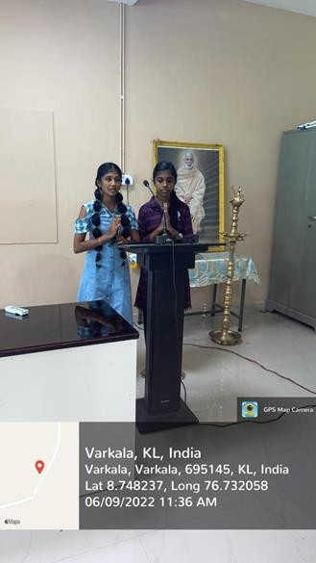
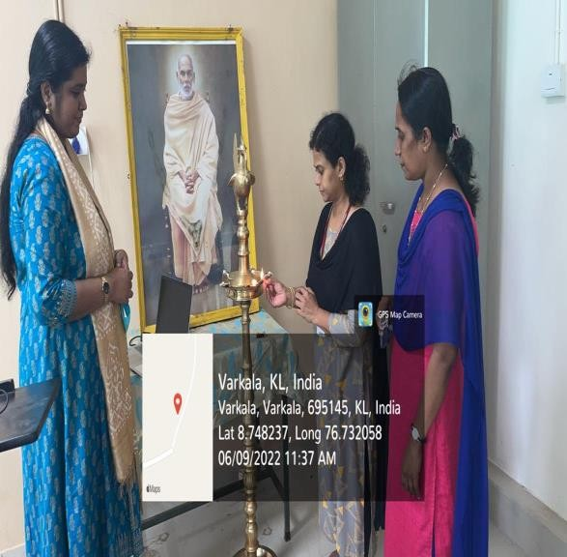

Prayer
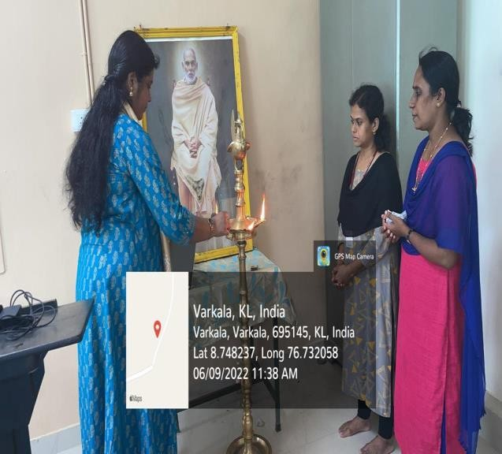
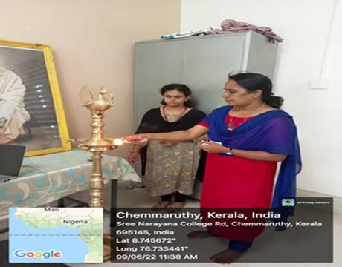

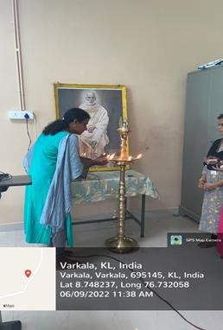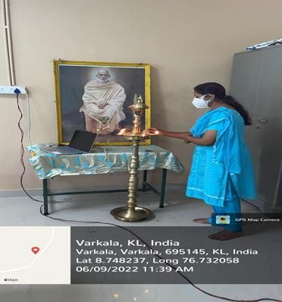

Inauguration
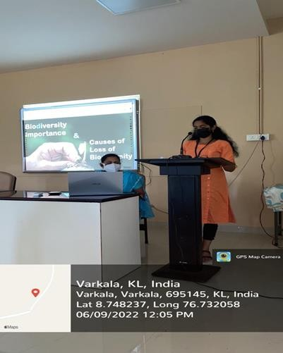
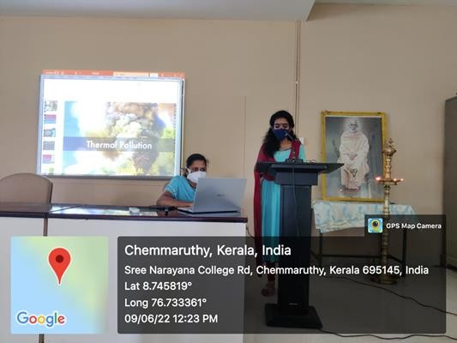
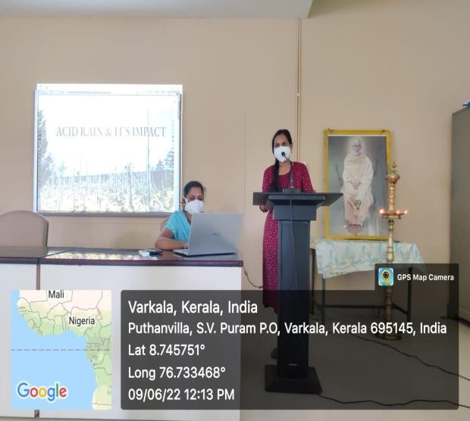
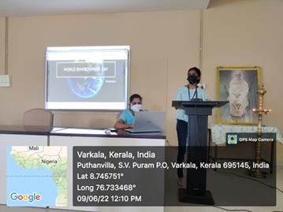

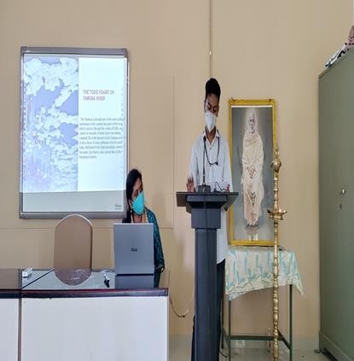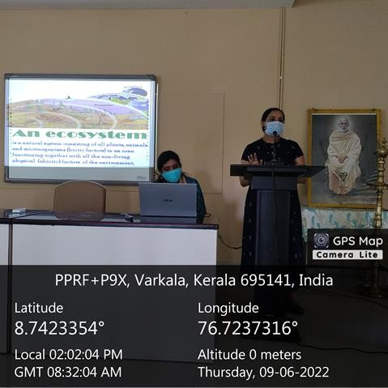
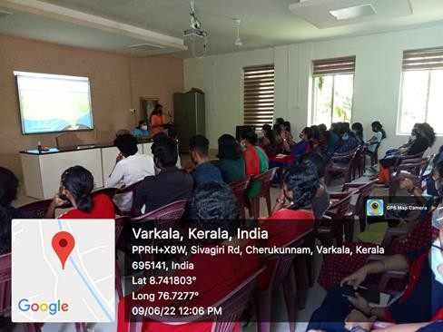
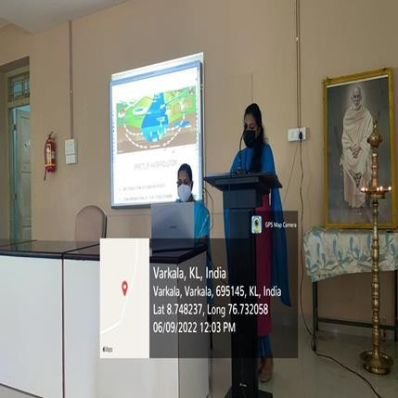

Powerpoint Presentation
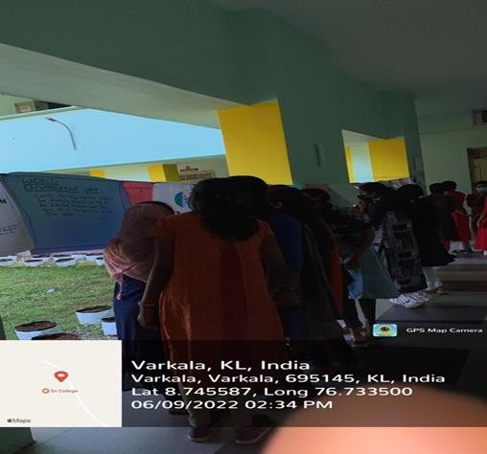
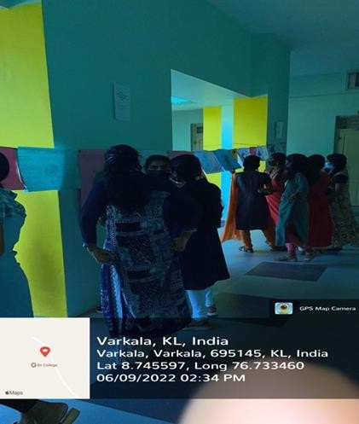

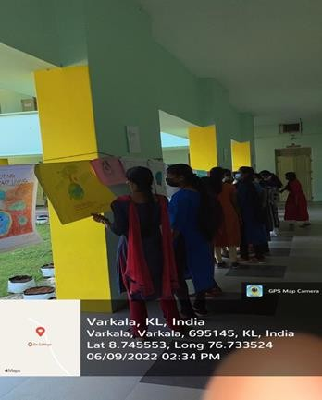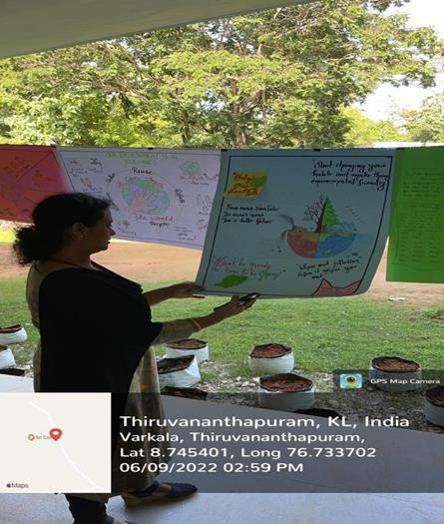
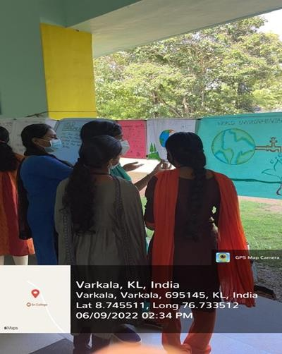
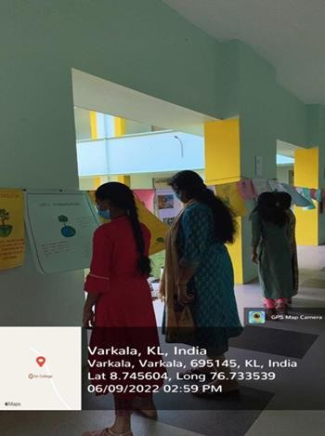

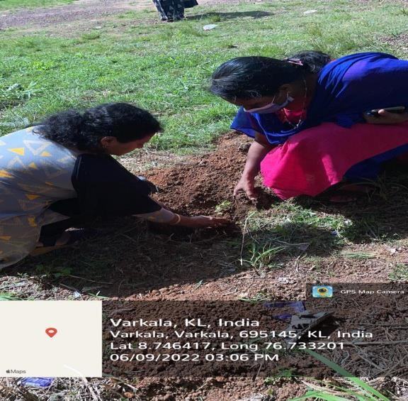
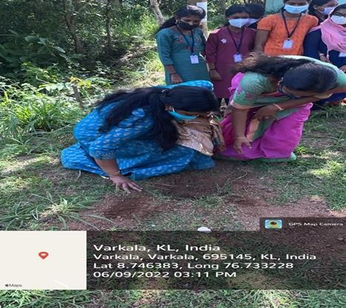
Poster Presentation

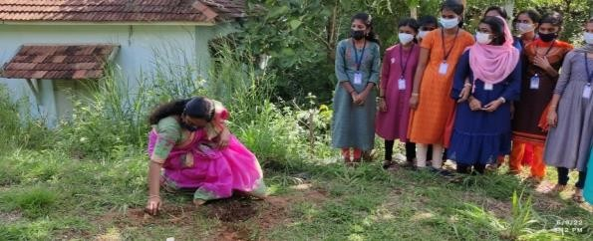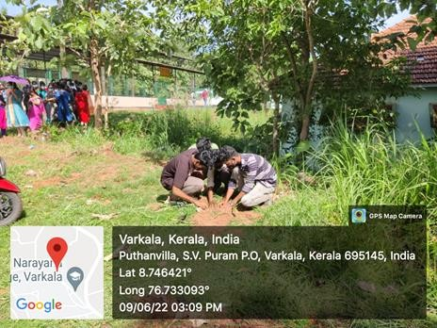
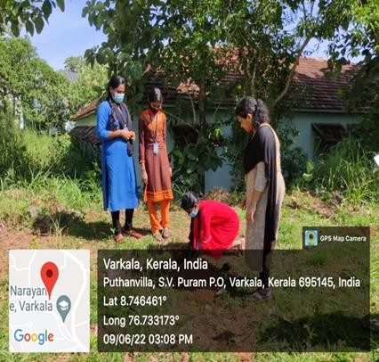
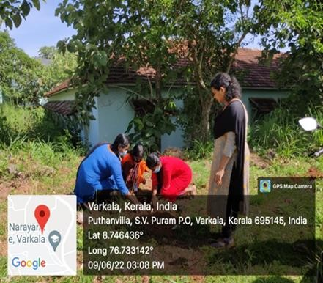

Planting Saplings

